**System Verilog code**

Create a combinational RTL model for a 4-bit expandable carry lookahead adder (CLA). **You do not need to use modules for full or half adders.**

Recall that a behavioral dataflow model uses only continuous assignment (assign) statements with/without gate delays.

Use below Gate delays:

* AND gate 2ns
* OR gate 2ns
* XOR gate 3ns

Using the 4-bit CLA module you created and verified using the test bench, create an expandable 8-bit adder and simulate it with the testbench provided.

Your design modules MUST be declared as follows:

***module CLA4Bit(ain, bin, cin, sum, cout);***

***input [3:0] ain, bin;***

***input cin;***

***output logic [3:0] sum;***

***output logic cout;***

***module CLA8Bit(ain, bin, cin, sum, cout);***

***input [7:0] ain, bin;***

***input cin;***

***output logic [7:0] sum;***

***output logic cout;***

**Refer the schematic below for a 4-bit CLA carry out logic:**

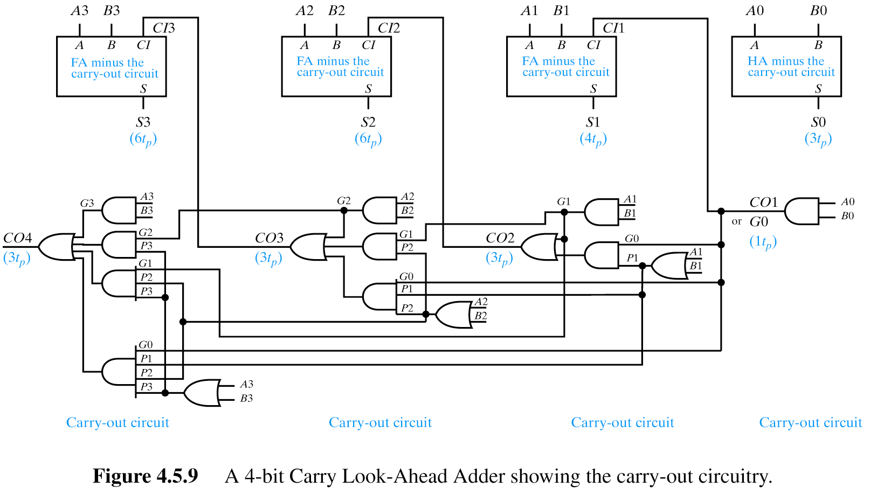

**Refer below equations for carry out logic:**

Cout = A⋅B + A⋅Cin + B⋅Cin

Cout = A⋅B + Cin ⋅ (A+ B)

Cout = G + Cin ⋅ P

where,

Gn = An.Bn and Pn = An + Bn

G (carry generate) is dependent upon current stage's ability to generate a carry.

P (carry propagate) is dependent upon current (and prior) stages’ ability to propagate a carry.

A carry is generated at a stage i if it is generated by stage i’s inputs (Ai,Bi) or by any prior stage and propagated by every succeeding stage.

Hence,

*CO1 = G0 + CI0.P0*

*=> CO1 = G0*

*CO2 = G1 + CI1.P1*

*=> CO2 = G1 + CO1.P1*

*=> CO2 = G1 + G0.P1*

*CO3 = G2 + CI2.P2*

*=> CO3 = G2 + CO2.P2*

*=> CO3 = G2 +(G1 + G0.P1).P2*

*=> CO3 = G2 +G1.P2 + G0.P1.P2*

And so on...

**And the equation for Sum output will be as follows:**

*S = A ^ B ^ CIN ;*

(Hint: For the sum output, you need to figure out the logic for CIN using the schematic, it is not straight forward, unlike inputs A and B which can be used as it is!)

**How to use the test bench provided?**

Part 1: Testing your 4 bit CLA design module.

1. Create a top module as shown below and add this module to your CLA4Bit module and save this single file as CLA4Top.sv:

***module CLA4Top;***

***parameter nBITS = 4;***

***logic [nBITS - 1 : 0] ain, bin, sum;***

***logic cin, cout;***

***// instantiate your 4 bit CLA design module here***

***// instantiate the test bench module as follows***

***test #(4) TB(.*);***

***endmodule***

1. Add CLA4Top.sv and test.sv to your project in QuestaSim.
2. Simulate the CLA4Top.sv file
3. Save the transcript.

Part 2: Testing your 8 bit CLA design module.

1. Create a top module as shown below and add this module to your CLA8Bit module and save this single file as CLA8Top.sv:

***module CLA8Top;***

***parameter nBITS = 8;***

***logic [nBITS - 1 : 0] ain, bin, sum;***

***logic cin, cout;***

***// instantiate your 8 bit CLA design module here***

***// instantiate the test bench module as follows***

***test #(8) TB(.*);***

***endmodule***

1. Add CLA8Top.sv and test.sv to your project in QuestaSim.
2. Simulate the CLA8Top.sv file
3. Save the transcript.

You are encouraged to do further readings on the working of a CLA and ask questions if things are unclear.

Submit your System Verilog code for both design modules with the transcript via D2L in a zipped file named as **HW1.zip** with names as follows:

***CLA4Top.sv your 4-bit CLA design module***

***CLA8Top.sv your 8-bit CLA design module***

***transcripts for both simulations***

**NOTE**: If you do not follow these instructions for declaring, naming and submitting your modules to D2L, you will receive partial credit even if your answers are correct.